中华人民共和国驻***大使馆签证处
Visa Section, Embassy of the People's Republic of China in ***

尊敬的签证官员：

我谨代表第十一届泛华统计协会大会组织委员会诚邀**大学**博士出席会议并做报告。本次会议在浙江省杭州市举办，举办时间为2019年12月19日至12月22日。**博士相关信息如下：

姓名： |  | 性别：
出生日期： | 年 月 日 | 国籍：
护照号码： |  | 护照到期日： | 年 月 日
单位： |  | 职位：
请给予**博士办理单次入境签证以便其参加本次学术会议。我们已确认他订妥往返机票，参会期间的陆地费用由其个人承担。有任何疑问请随时与我联系（+86 0571-88208268）。
望予办理为盼！

Dear Visa Officer：

We are pleased to invite Dr. ** to make a presentation at the 11th ICSA International Conference in Hangzhou for 4 days between 19 December 2019 and 22 December 2019. His information is as follows：
Full name: |  | Gender：
Date of Birth： |  | Nationality：
Passportnumber： |  | Passport expiry date：
Work unit： |  | Job Title:
Please grant a single entry visa for Dr. ** to travel. We confirm that he will be in receipt of a return ticket, and all expenses for his journey will be met by himself. Should you wish to discuss this application further, please do not hesitate to contact me.

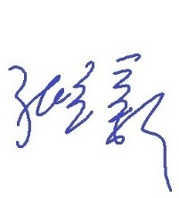
Yours faithfully,
浙江大学数据科学研究中心
The Center for Data Science, Zhejiang University
2019年10月25日

